

**MEMORANDUM OF UNDERSTANDING**

This is a document validating an agreement between **MR. OGABOR JOHN AND MR. ORIMOLADE TUNOLASE** for the collaborative of 20% interest over a sum of **ONE MILLION, SIX HUNDRED THOUSAND NAIRA ONLY (₦1,600,000) paid on the 01st of June, 2020.**

There is a binding agreement to pay the initial capital invested, alongside the interest, **ONE MILLION, NINE HUNDRED AND TWENTY THOUSAND NAIRA ONLY (₦1,920,000) on the 02nd of July, 2020** by **MR. OGABOR JOHN TO MR. ORIMOLADE TUNOLASE.**

Attached with this document is an evidence of payment by **MR. ORIMOLADE TUNOLASE.**

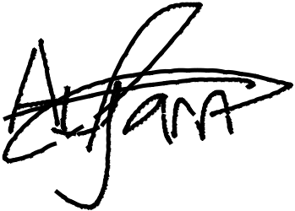

_________________________

_~~__~~_____~~___~~_~~_~~___________



**MR. ORIMOLADE TUNOLASE**

**MR. OGABOR JOHN**

***(CEO, JOHN INVESTMENTS)***